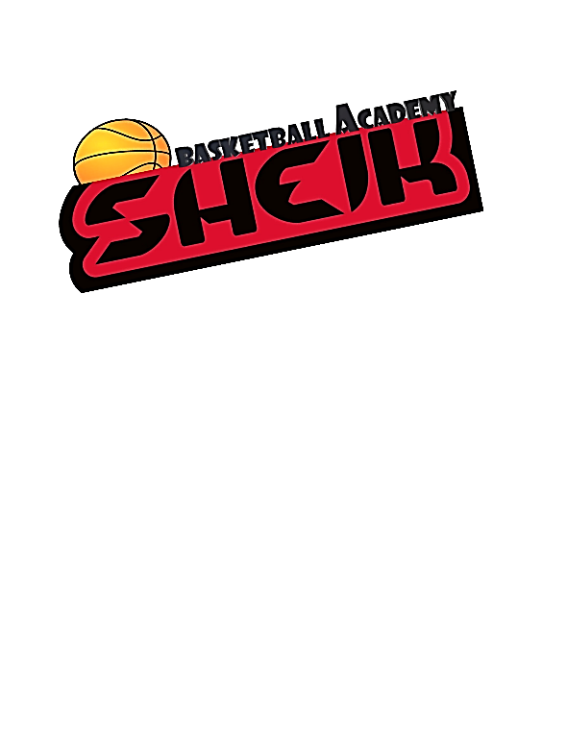Minor Waiver/Release
RELEASE OF LIABILITY FOR MINOR PARTICIPANTS
READ BEFORE SIGNING
IN CONSIDERATION OF ____________________________________{(Child/ Player’s Name)}, my child/ward, being allowed to participate in any way in the SoCal Sheik related events and activities, the undersigned acknowledges, appreciates, and agrees that:
The risk of injury to my child from the activities involved in these programs is significant, including the potential for permanent disability and death, and while particular rules, equipment, and personal discipline may reduce this risk, the risk of serious injury does exist; and,
- FOR MYSELF, SPOUSE, AND CHILD, I KNOWINGLY AND FREELY ASSUME ALL SUCH RISKS, both known and unknown, EVEN IF ARISING FROM THE NEGLIGENCE OF THE RELEASES or others, and assume full responsibility for my child’s participation; and,
- I willingly agree to comply with the program’s stated and customary terms and conditions for participation. If I observe any unusual significant concern in my child’s readiness for participation and/or in the program itself, I will remove my child from the participation and bring such attention of the nearest official immediately; and,
- I myself, my spouse, my child, and on behalf of my/our heirs, assigns, personal representatives and next of kin,
HEREBY RELEASE AND HOLD HARMLESS SoCal Sheik founder, its directors,
officers, officials, agents, employees, volunteers, other participants, sponsoring agencies, sponsors, advertisers, and if applicable, owners and lessors of premises used to conduct the event (“Releasees”), WITH RESPECT TO ANY AND ALL INJURY, DISABILITY,
DEATH, or loss or damage to person or property incident to my child’s involvement or participation in these programs, WHETHER ARISING FROM THE NEGLIGENCE OF THE RELEASEES OR OTHERWISE, to the fullest extent permitted by law.
- I, for myself, my spouse, my child, and on behalf of my/our heirs, assigns, personal representatives and next of kin, HEREBY INDEMNIFY AND HOLD HARMLESS all the above Releasees from any and all liabilities incident to my involvement or participation in these programs, EVEN IF ARISING FROM THEIR NEGLIGENCE, to the fullest extent permitted by law.
- I, the parent/guardian, assert I have explained to my child/ward: the risks of the activity, his/her responsibilities for adhering to the rules and regulations, and that my child/ward understands this agreement.
I, FOR MYSELF, MY SPOUSE, AND CHILD/WARD, HAVE READ THIS RELEASE OF
LIABILITY AND ASSUMPTION OF RISK AGREEMENT, FULLY UNDERSTAND ITS TERMS, UNDERSTAND THAT WE HAVE GIVEN UP SUBSTANTIAL RIGHTS BY SIGNING IT, AND SIGN IT FREELY AND VOLUNTARILY WITHOUT ANY INDUCEMENT.

_________________________________________________________
(PRINT NAME)
_____________________________________________________
(PARENT/GUARDIAN SIGNATURE)
Date Signed: ______________________________________
UNDERSTANDING OF RISK
I understand the seriousness of the risks involved in participating in this program, my personal responsibilities for adhering to rules and regulation, and accept them as a participant.
_______________________________________________________
(PARTICIPANT SIGNATURE) Date Signed: ______________________________________

Player Last Name: _____________________ Player First Name: _____________________
Parent Name(s): ____________________________________________________________
Parent Cell Number: ____________________ Home Number: _______________________
Address: __________________________________________________________________
Emergency Contact Person & Phone (if parent can’t be reached):
__________________________________________________________________________ Medical Condition(s) we should know of:
__________________________________________________________________________
Medical Insurance Carrier: ___________________________________
Policy Number: ____________________________________
Group: ______________________________________

